**Program Run**

The following demonstrates a full program run for Lab 6. The user is given four options to choose from. The first option allows users to create their own graphs. Once their graph is created, users can insert edges, delete edges, create different graphical representations, perform breadth first search to find a path, perform depth first search to find a path, display the graph, or print the graph. The full program run is below.

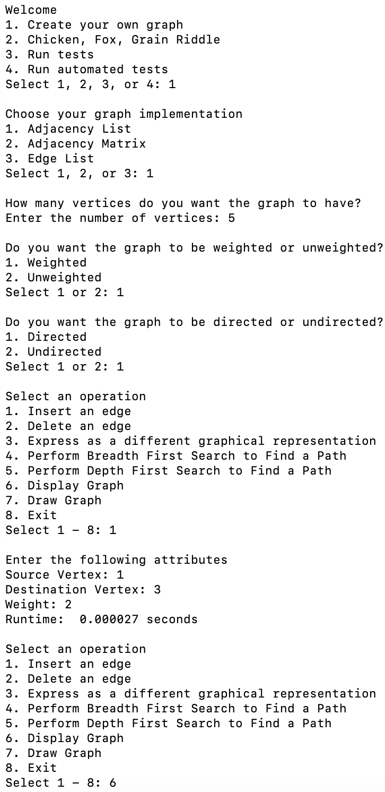

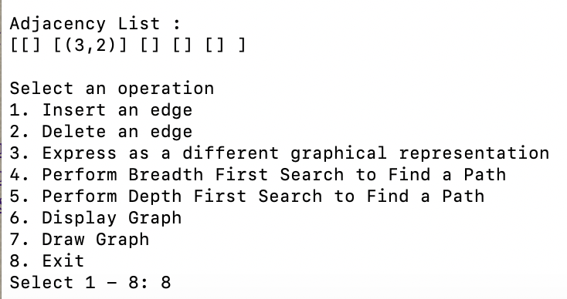

The second option that the user can choose is to solve the fox, grain, chicken, person riddle. The user can select the graph implementation that they want to use to solve the riddle as well as the search algorithm (breadth first search or depth first search). A sample run using breadth first search is below.

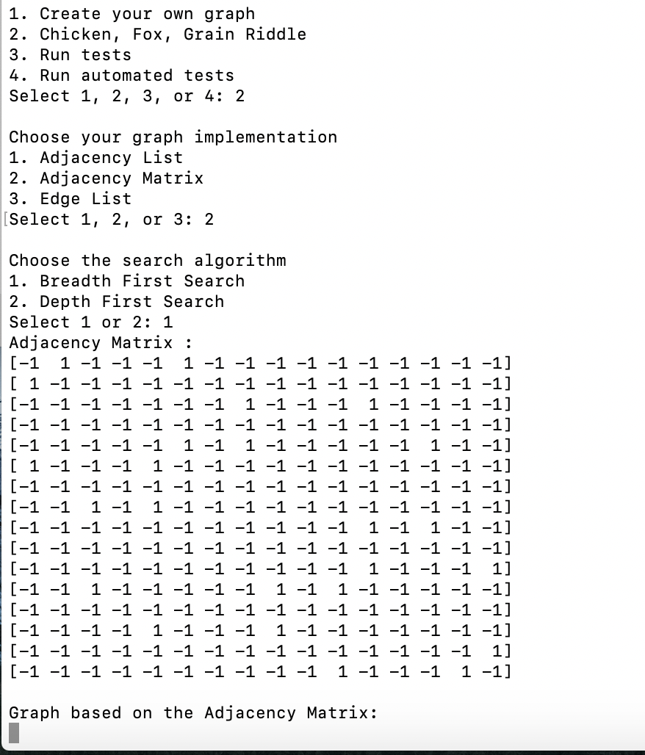

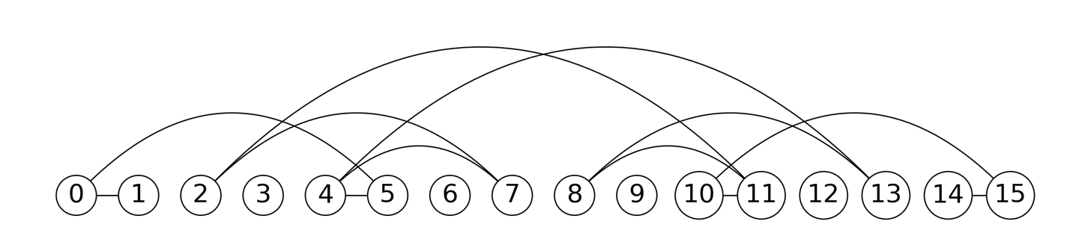

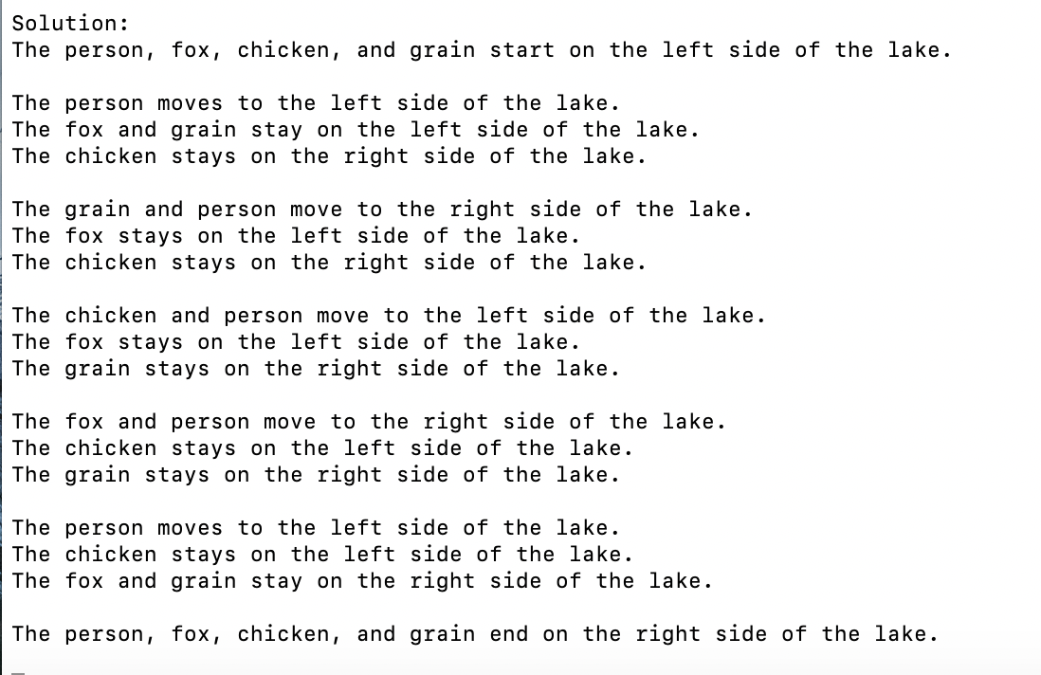

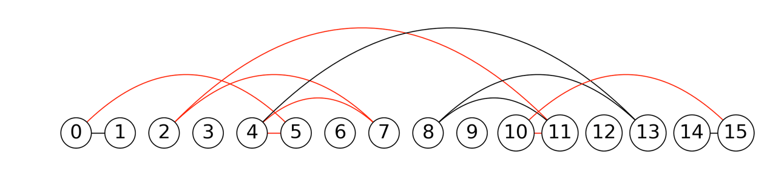

The third option allows users to run the run_test.py file provided. Users can select what graph to use to run the tests. A sample run using an edge list is demonstrated below.

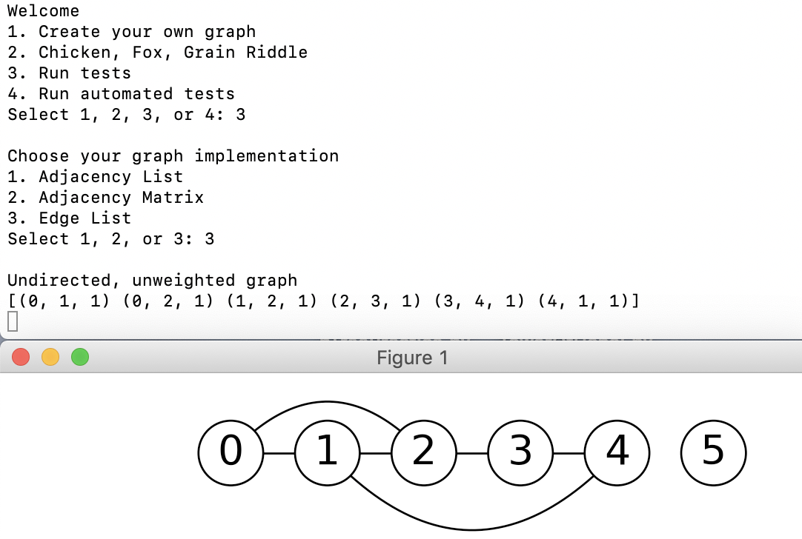

------

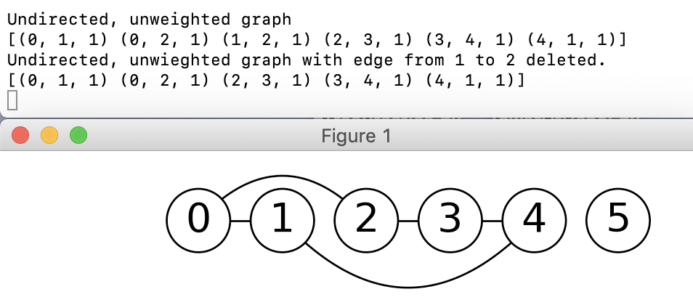

------

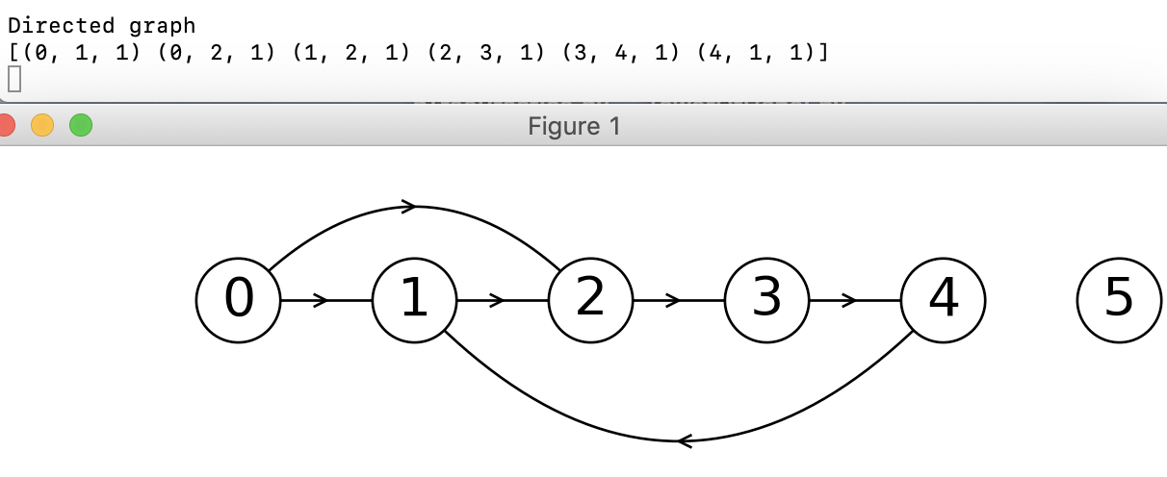

------

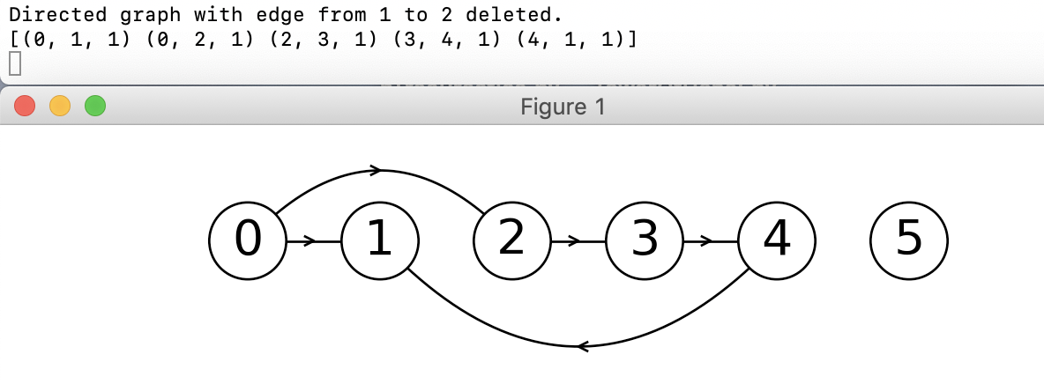

------

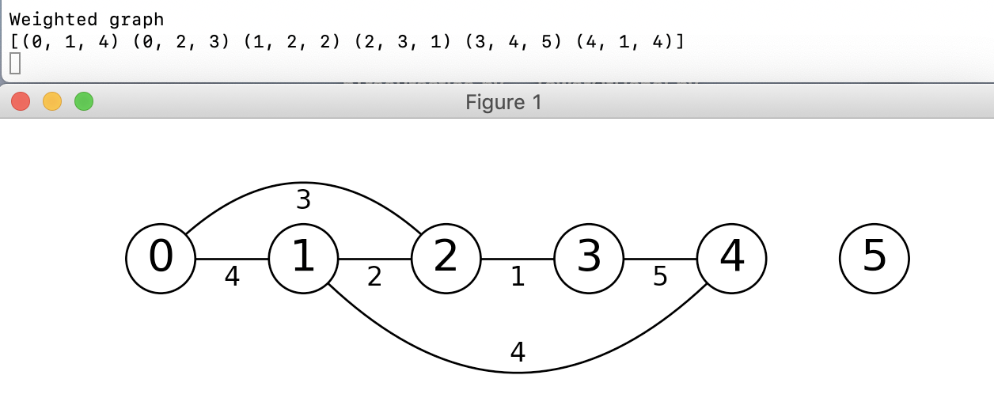

-----

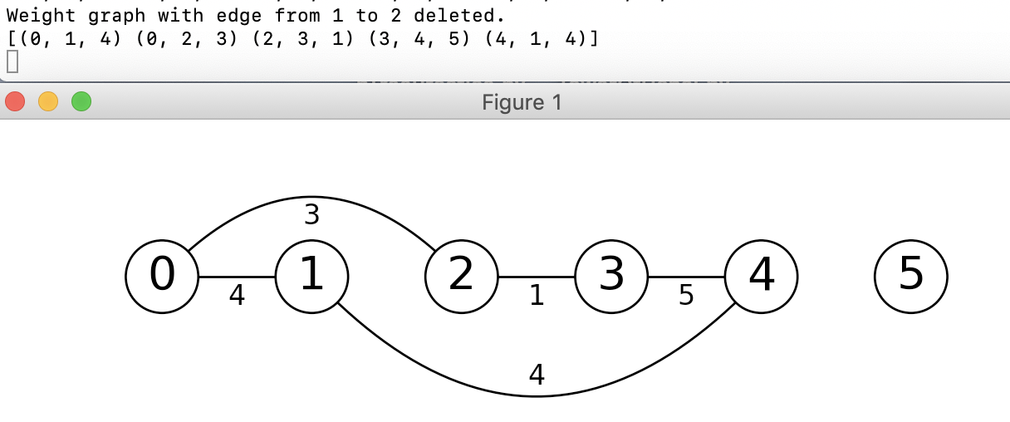

-------

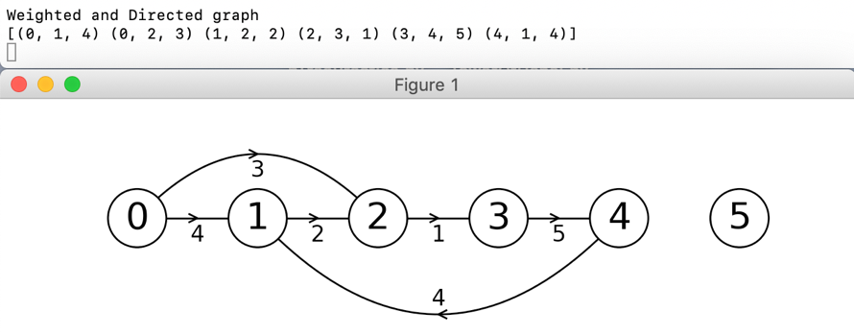

------

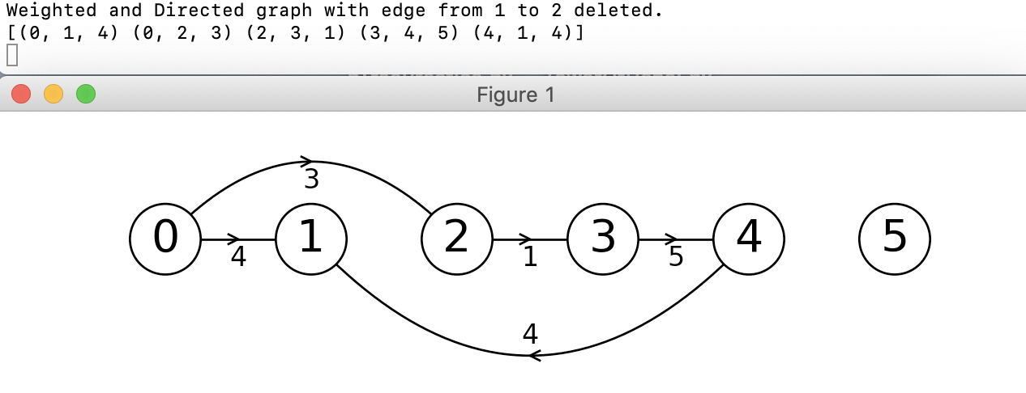

-------

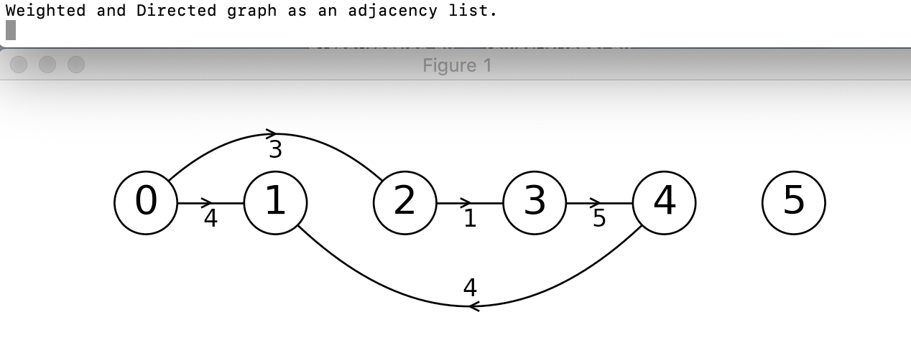

The last option allows users to run automated test on the three different graph types as undirected, directed, weighted, and directed and weighted. The runtimes are calculated for the operations. The user can also select whether they want to print the resulting graph for each test. A sample test run for insertion of graphs with 10 vertices is shown below.

